SIMATS ENGINEERING (SAVEETHA SCHOOL OF ENGINEERING)
Department of Computer Science and Engineering
CO3 ASSESSMENT TOOL 2 – Code Review & Repository Evaluation

Course Code: | CSA10 / CSA1063 | Course Title: | Software Engineering
CO Assessed: | CO3 | Assessment: | Assessment Tool 1 – Code Review & Repository Evaluation
Weightage: | 20% | Total Marks: | 25
CO3 Statement: | Build full-stack applications with an emphasis on containerization, version control, and collaborative development
Student Name: | M.DINESH KUMAR REDDY | Reg. No.: | 192372251
Date: | 11/08/2026 | Duration: | 60 minutes

Code of Conduct
I M.DINESH KUMAR REDDY 192372251_________ (Name / Reg No) certify that this submission is my original work and that I have adhered to the guidelines specified for this assesment. I understand that any violation of academic integrity rules will result in disciplinary action.
Signature of the Student: _________________________

Smart Disaster Relief Coordination Platform
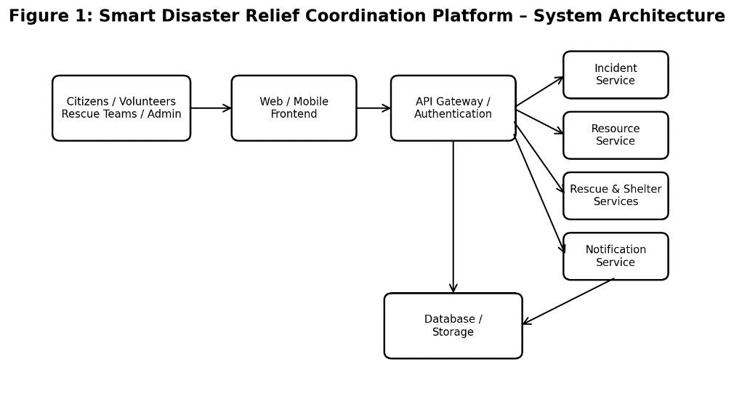

1. Problem Overview
The Smart Disaster Relief Coordination Platform is a centralized software system designed to coordinate disaster response activities such as emergency reporting, rescue-team deployment, resource allocation, shelter management, volunteer coordination, and real-time communication. It connects disaster-management authorities, rescue teams, hospitals, volunteers, donors, and affected citizens so relief operations can be planned and monitored efficiently.
The main objectives are to reduce response time, improve resource utilization, maintain accurate information, and provide reliable communication during emergencies.

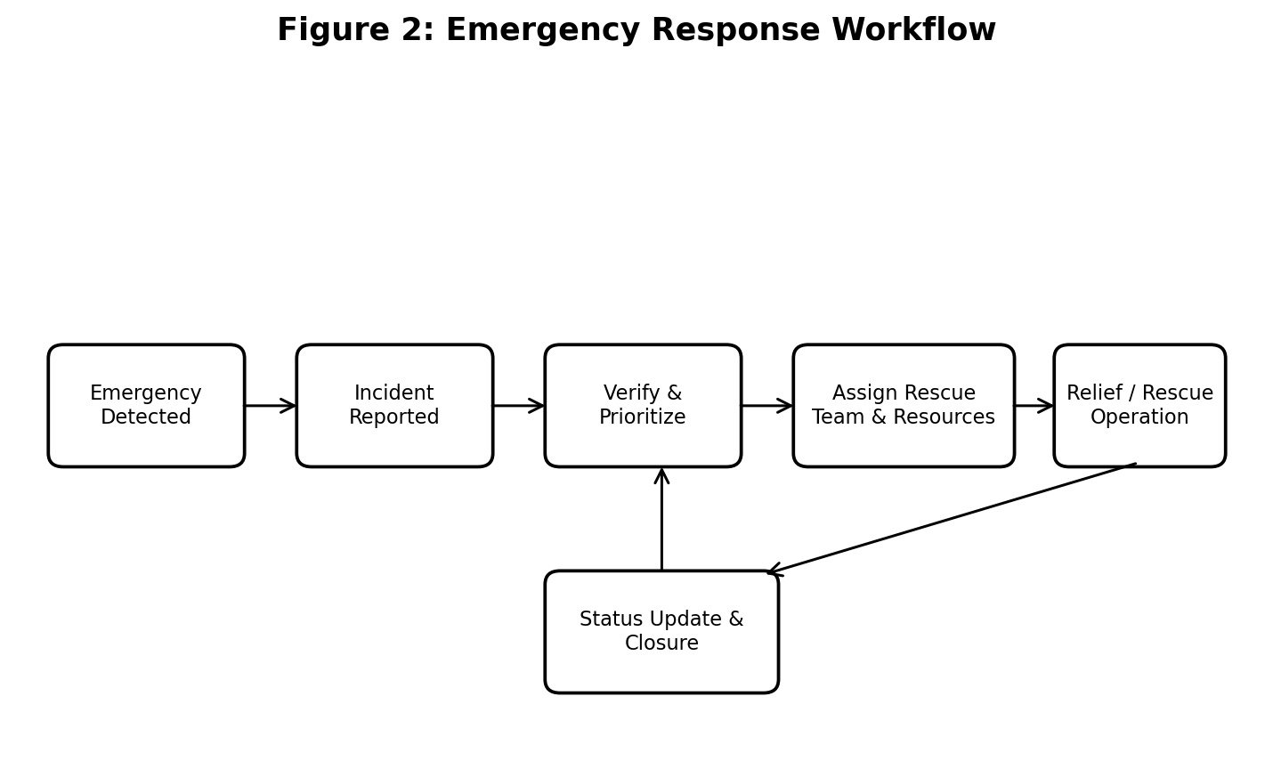
• Emergency incident reporting and location tracking.
• Rescue-team assignment and task management.
• Relief-material and resource allocation.
• Shelter and affected-person management.
• Volunteer and donor coordination.
• Real-time alerts, notifications, and status updates.
• Administrative dashboard and disaster-operation monitoring.

2. Repository Organization
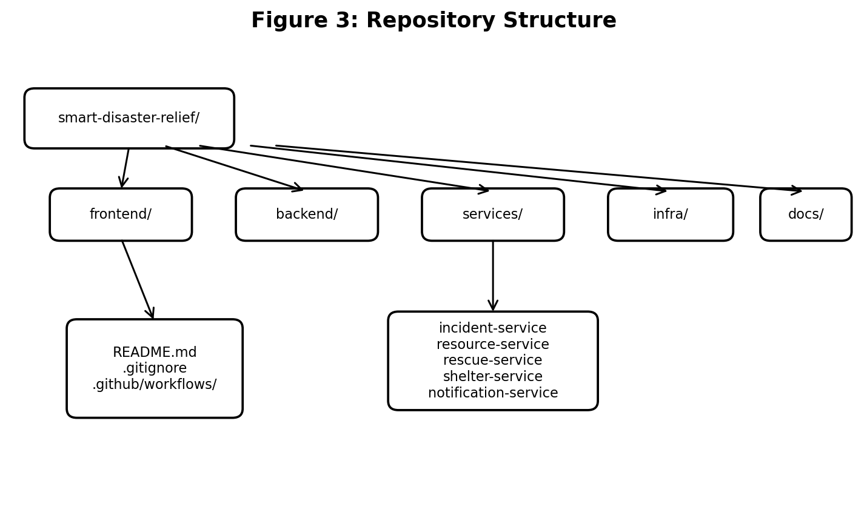
The repository is organized as a modular full-stack application with separate areas for the frontend, backend services, shared utilities, infrastructure, documentation, and testing. This separation improves maintainability and allows developers to work on independent disaster-management modules.
• frontend/ – citizen, volunteer, rescue-team, and administrator interfaces.
• backend/ – APIs and core disaster-coordination logic.
• incident-service/ – emergency reports and incident status.
• resource-service/ – food, medicine, vehicles, equipment, and relief resources.
• rescue-service/ – rescue-team assignments and response activities.
• shelter-service/ – shelters, capacity, and affected-person information.
• notification-service/ – emergency alerts and communication.
• database/ – database configuration and initialization.
• infra/ – Docker Compose and deployment configuration.
• docs/ – architecture, setup, API, and user documentation.
• .github/workflows/ – automated CI checks and collaborative development.
The layout supports collaboration because each functional area has a clear responsibility and unrelated modules can be modified independently.
3. Code Quality Review
Code Example 1 – Incident Validation (Python/FastAPI)
@app.post("/api/incidents")
def create_incident(data: IncidentCreate):
if not data.location:
raise HTTPException(400, "Location is required")
if data.severity not in ["LOW", "MEDIUM", "HIGH", "CRITICAL"]:
raise HTTPException(400, "Invalid severity")
incident = incident_service.create(data)
return {"status": "created", "incident_id": incident.id}
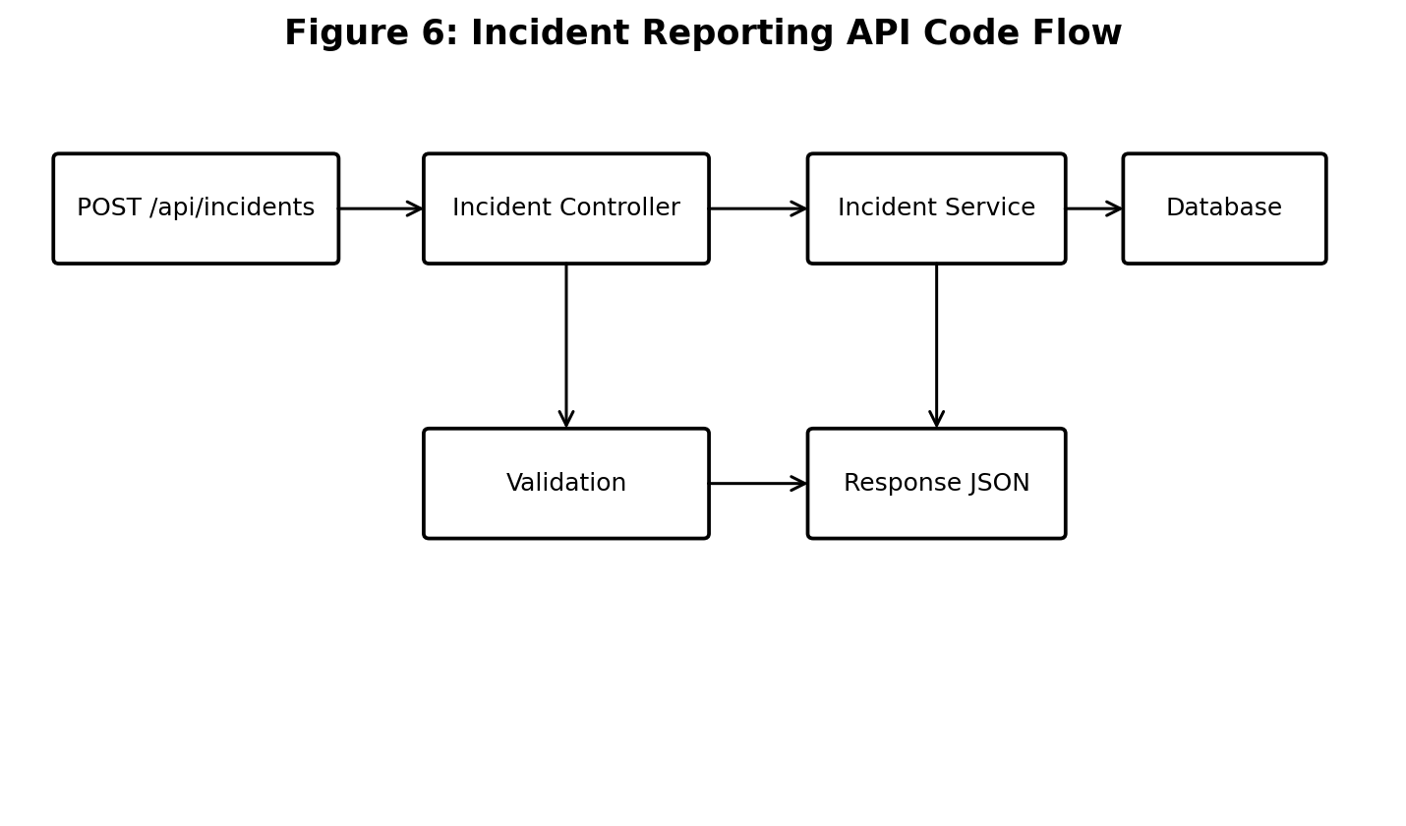
The code should follow meaningful naming conventions, modular functions, reusable components, consistent formatting, and appropriate documentation. Business logic should be separated from interface and database-access code.
• Readability through meaningful class, function, variable, and API names.
• Modularity of incident, rescue, resource, shelter, and notification functions.
• Maintainability through reusable services and utility modules.
• Security through authentication, authorization, input validation, and protected configuration.
• Documentation of important APIs and setup procedures.
The modular design makes it easier to add new disaster-management features without changing the entire application. Improvements should focus on automated code-quality checks, centralized error handling, validation, and consistent logging.

4. Version Control Evaluation
Code Example 2 – Git Workflow
git checkout develop
git checkout -b feature/incident-reporting
git add .
git commit -m "feat(incident): add emergency reporting API"
git push origin feature/incident-reporting
# Create Pull Request -> Code Review -> Merge
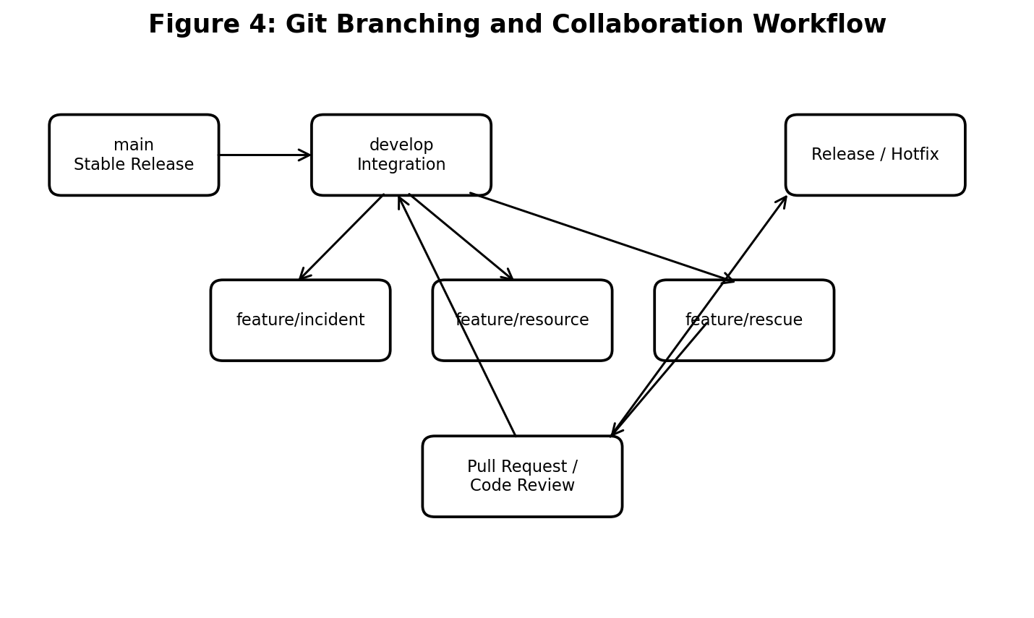
Git is used to maintain the development history of the platform. A suitable strategy uses main for stable releases, develop for integration, feature/* branches for individual functions, release/* branches for final testing, and hotfix/* branches for urgent corrections.
• feature/incident-reporting – emergency reporting.
• feature/resource-management – relief-resource allocation.
• feature/rescue-coordination – rescue-team assignment.
• feature/shelter-management – shelter management.
• feature/notifications – emergency notifications.
Commit messages should clearly describe changes, for example: feat(incident): add emergency reporting API. Version control supports parallel development, review, conflict resolution, traceability, and rollback.

5. Code Testing and Validation
Code Example 3 – API Test
def test_create_incident(client):
payload = {
"location": "Chennai",
"severity": "HIGH",
"description": "Flood reported"
}
response = client.post("/api/incidents", json=payload)
assert response.status_code == 201
assert "incident_id" in response.json()
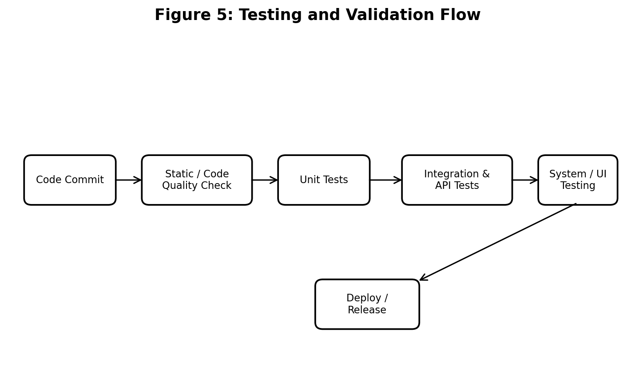
The platform should be validated through unit, integration, API, and functional testing. Testing is especially important because incorrect disaster information or resource allocation can affect emergency response.
• Test incident creation with valid and invalid emergency information.
• Test assignment of available rescue teams to an incident.
• Test resource allocation and prevention of allocation beyond available stock.
• Test shelter registration and capacity validation.
• Test role-based access for citizens, volunteers, rescue teams, and administrators.
• Test emergency notifications and status updates.
• Test frontend-backend API communication.
Execution screenshots should demonstrate successful requests, validation errors, database updates, dashboard results, and notification responses.
6. Repository Documentation
Code Example 4 – Docker Compose
services:
incident-service:
build: ./services/incident-service
ports:
- "8001:8000"
environment:
DATABASE_URL: ${DATABASE_URL}
depends_on:
- postgres
postgres:
image: postgres:16
volumes:
- pgdata:/var/lib/postgresql/data
The repository documentation should include a README, installation instructions, usage guide, dependencies, architecture, API information, testing instructions, and deployment steps.
• README.md – project overview, features, prerequisites, setup, and usage.
• Installation guide – dependency installation and service startup.
• API documentation – incident, rescue, resource, shelter, and notification endpoints.
• Docker documentation – container build and deployment commands.
• Testing documentation – test commands and expected results.
7. Code Review Findings and Recommendations
The platform benefits from modular organization, clear separation of responsibilities, Git-based collaboration, and containerized deployment. Recommended improvements are:
• Add automated linting and formatting checks in CI.
• Add unit and integration tests for critical workflows.
• Protect main and require pull-request reviews.
• Store passwords, API keys, and other secrets outside the repository.
• Add centralized logging and monitoring.
• Use Docker for consistent development and deployment environments.
• Implement database backup and recovery procedures.
• Improve scalability for large numbers of users and simultaneous disaster incidents.

Code Review Summary Table
Module | Code Check | Expected Result | Status
Incident Service | Input validation | Invalid data rejected | Pass
Resource Service | Stock validation | No over-allocation | Pass
Rescue Service | Team assignment | Available team selected | Pass
Shelter Service | Capacity check | Capacity cannot be exceeded | Pass
Notification Service | Alert delivery | Correct users notified | Pass

